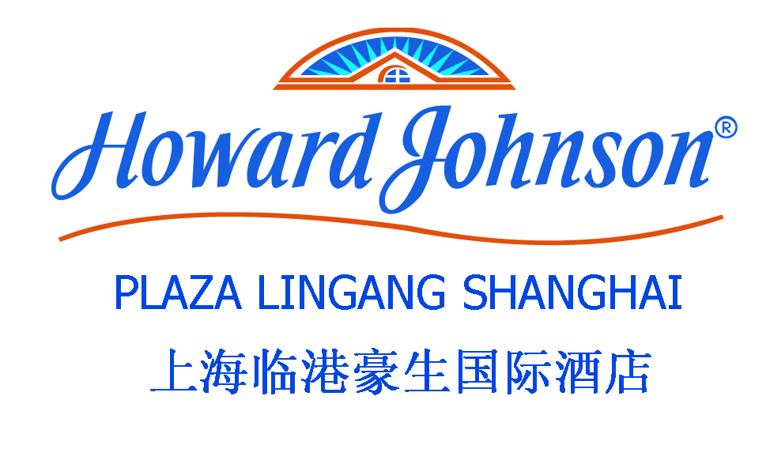
预 定 要 求 单
RESERVATION REQUEST

Reservation Fax No. | +86-21-38281818
E-Mail | sales.shanghai@hojolingang.com
Deadline of Reservation | 2007-03-05

*预订公司名称/ 预订代理人名称  BOOKING COMPANY/AGENT NAME |  |  |  | *联络人/ 电话/ 传真  CONTACT PERSON/TEL/FAX
*姓名  NAME |  |  |  | 身份状况  STATUS
*到店日期  ARRIVAL DATE |  |  | *离店时间  DEPARTURE DATE |  |  |  | *客人数量  NO.OF GUESTS
预订种类  TYPE OF ACCOMMODATION |  |  |  | 价格  RATE RMB660.net/ per day/per room
*付款方式  METHOD OF PAYMENT  D.B.C.公司付账  D.B.A.旅行社社或网络中心付账  P.O.A.自付（所有帐目） |  |  |  | 特殊需求  SPECIAL REQUESTS
  *担保GTD
日期  DATE |  | 预订员名称  RES.CLERK |  |  | 确认号  CFM.NO.
In order hold the rooms for you / your guests, would you please provide us the credit card information with the following details as guarantee, otherwise, hotel will cancel the non-guaranteed reservation without notice.
国家  COUNTRY | 国籍  NATIONALITY |  |  |  |  | *出生年月  DATE OF BIRTH
护照种类  VISA TYPE | 签证号码  VISA NO. |  |  |  |  | 签证有效期  VISA EXPIRY
*护照号码  PASSPORT NO. | 签发地  PLACE OF ISSUE |  |  |  |  | 签发日期  DATE OF ISSUE
*信用卡种类  CREDIT CARD TYPE | *信用卡号码  CREDIT CARD NO. |  |  |  |  | *有效期  VALID PERIOD

- CANCELLATION AND AMENDMENT POLICY 取消或变更预定
One night’s room charge of each guaranteed reservation will be charged for cancellations or amendment less than 7 days prior to the scheduled arrival date.至少提前七天(原定到达日期)传达取消/变更信息，否则酒店将收取一晚的房费。
- NO SHOW POLICY 未入住
Should you or your guests with a guaranteed reservation not arrive on the scheduled arrival date, one-night’s room charge will be charged as no-show penalty. 如预订后未入住，酒店将收取一晚的房费，且酒店将自动释放房间。
- EARLY CHECK OUT 提前退房
Unless approved by the Hotel Management, should you or your guests early check out, one night’s room charge will be charged as late cancellation or amendment.除非得到酒店负责人的许可，否则酒店将收取一晚的房费。

